

Project Name: ONLINE DRIVER HIRING SYSTEM

Branch PG-DAC September- 2021.

Documentation On

**“**ONLINE DRIVER HIRING SYSTEM **”**

PG-DAC September 2021

**Guided By: Prof. Bakul Joshi**

Submitted By :

**Group No: 09**

* **Ashraf Pathan 210943020009**
* **Revan Kante 210943020034**
* **Parag Taide 210943020101**
* **Narendra Walvekar 210943020110**

**Table of Contents**

**1. Introduction 4**

1.1 Document Purpose **4**

1.2 Project Background **4**

1.3 Aim & Objectives **4**

**2. Business Requirements Overview**…………………………………………………………**5**

**3.Functional Requirements** **5**

3.1 Customer Module **5**

3.2 Driver Module **6**

3.3 Admin Module **6**

**4.** **Non-Functional Requirement………………………………………………………………6**

**5. Use Case Diagram 8**

5.1 Admin **8**

5.2 Customer **9**

5.3 Driver **10**

**6. Database Design 11**

1 Login **11**

2 Users **11**

3 Drivers …………………………………………………………………………………...**11**

4 Cities **11**

5 Bookings **12**

6 Customer payments **12**

7 Driver payments **12**

8 Ratings **13**

**7. E-R Diagram……………………………………………………………………………………….13**

**8. Snapshots 14**

**9. Conclusion 22**

**List of Figures**

**Use Case Diagrams**

Fig 1 Admin 8

Fig 2 Customer 9

Fig 3 Driver 10

Fig 4 ER Diagram 13

1. **Introduction:**
   1. **Document Purpose:**

This document communicates the business requirements and scope for developing Online Driver Hiring System. The scope of this document is to define the functional and non-functional requirements, business rules, and other constraints requirements.

## Project Background:

Despite the availability of plenty of public transport options, a car driver has its charm. Currently, there are many platforms available in the market for car/auto booking. But all these platforms provide the vehicle in addition to the driver which certainly costs more to the customer than just hiring a driver for the ride. Customers may have their vehicle, but self-driving takes the joy out of travel and binds them to the task of driving which may generate a lot of physical and mental stress, so they desire to be at ease during their journey. Many people own a vehicle but cannot drive, maybe because of sickness or physical disability or they just didn’t learn the driving; hence they prefer hiring a driver for their rides.

## Aim & Objectives:

* Our web-based Driver Hiring application proposed here will assist customers to find the best drivers for their rides 24/7.
* They can pay only after the completion of the ride.
* The booking will be flexible in that, the customer can cancel the booking before 2 days of the date of the ride without an extra charge.
* This system will also help drivers who don’t have their vehicles and freelancers who enjoy driving on the weekends.
* The driver can select the ride request as per his availability & convenience.

1. **Business Requirements Overview:**

* Online Driver hiring System is the public web application.
* Online Driver hiring System will be opened to the global, but in the phase 1, the main target is in major cities of India.
* There are mainly two types of users. One is the Customer and other is Driver.
* Customer can upload requirements for the driver by giving detailed information about the journey.
* Drivers can browse for the ride requirements from the customer’s side & confirm the ride with the respective customer.
* Online Driver hiring provides the functions which connect the customer and the driver efficiently.
* Online Driver hiring system could be maintained by Administrator.

# Functional Requirements Overview:

Online Car & Bike Rental System consists of four modules described as below.

1. Customer Module
2. Driver Module
3. Admin Module

# **3.1 Customer Module**

* Customer can register and create his own account.
* Customer can modify his profile.
* Customer can upload information about journey.
* Customer can make the payment.
* Customer can browse the pricing model.
* Customer can cancel his booking.
* Customer can rate & review the ride.
* Customer can see his ride history.

# **Driver Module**

* Driver can request for registration.
* Driver can see the upcoming rides.
* Driver can change the status of availability.
* Driver can accept the ride as per his convenience.
* Driver can submit company’s share.
* Driver can see his rides history.
* Driver can see his own average ratings.
* Driver can deregister from the system.

# **3.3 Admin Module**

* Admin can login.
* Admin can accept or reject the registration request of the drivers.
* Admin can generate reports about registered customers and drivers.
* Admin can generate report about all daily scheduled rides.
* Admin can generate rides history of customer & driver.
* Admin can see payment history of customer & driver.
* Admin can see ratings & review of customer & driver, and accordingly take corrective action on drivers considering the ratings.
* Admin can also control and see the payment activity.

1. **Non-Functional Requirement:**

* The website should use professional design, look and feel and color scheme.
* Users will have no limitations for accessing the application through Internet. The portal being an internet application, it is difficult specify exact number of visitor or users. Hence we will target the system to support between 5 and 10 million users on launch of phase 1.
* Being a public website, the site must follow general usability guidelines for menus, navigation, colors, links and other actions provided on the screens.
* The system should be designed in such a manner that user will be able to complete tasks in minimum number of steps.

## 5. Use-Case Diagram

**5.1 Admin:**

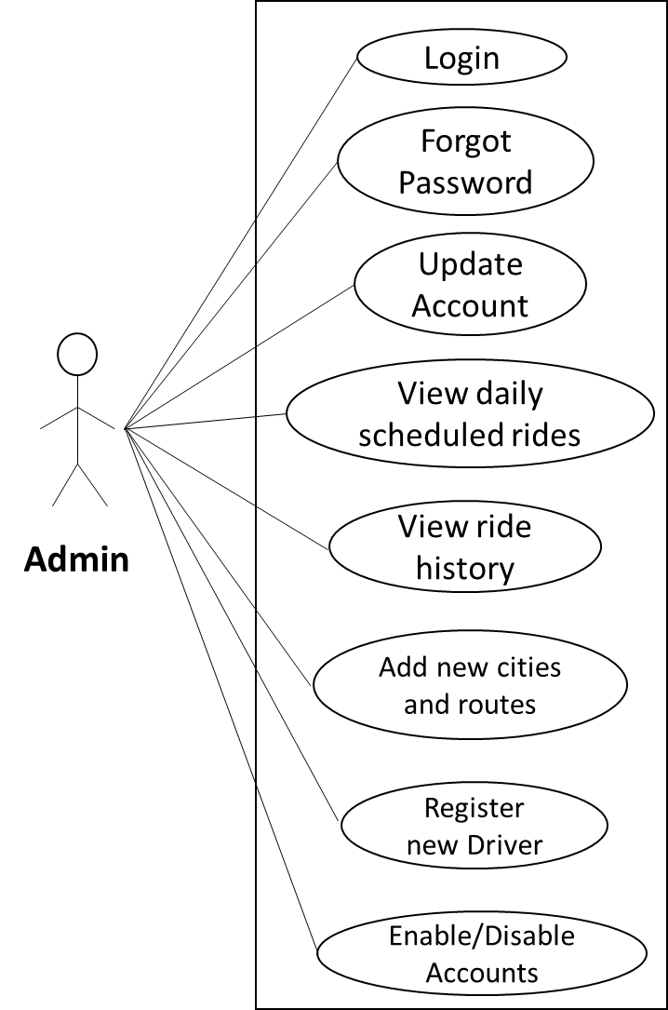

Fig. Use-Case Diagram for Admin

## 5.2 Customer:

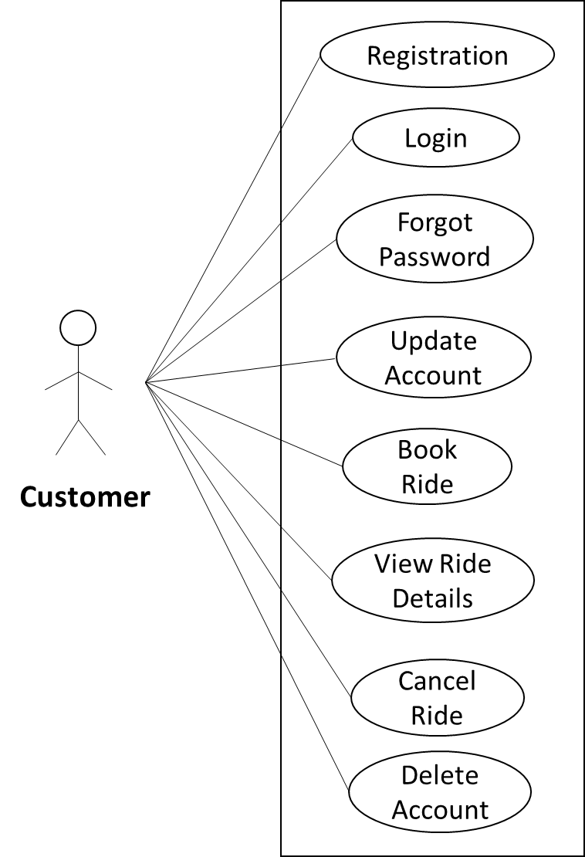

Fig. Use-Case Diagram for Customer

**5.3 Driver:**

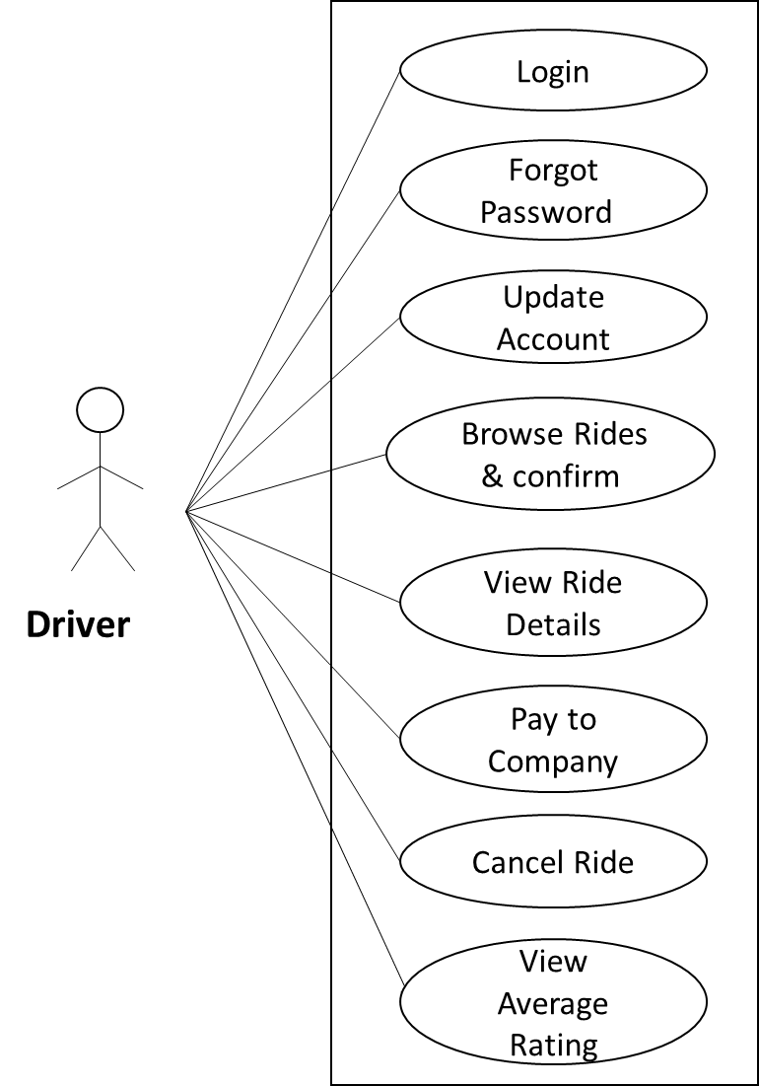

Fig. Use-Case Diagram for Driver

**6. Database Design:**

**1] Login table**

|  |  |  |  |  |  |
| --- | --- | --- | --- | --- | --- |
| **Field** | **Type** | **Null** | **Key** | **Default** | **Description** |
| login_id | Integer | No | Primary |  | Login ID |
| email_id | Varchar(45) | No | Unique |  | Email of Customer |
| password | Varchar(12) | No |  |  | Account Password |
| role | Varchar(45) | No |  |  | User role |
| security_que | Varchar(100) | No |  |  | Security Question |
| security_ans | Varchar(100) | No |  |  | Security Password |
| user_id | Integer | No | Foreign |  | Reference to user_id (Tbl_Users) |

**2] Users table**

|  |  |  |  |  |  |
| --- | --- | --- | --- | --- | --- |
| **Field** | **Type** | **Null** | **Key** | **Default** | **Description** |
| user_id | Integer | No | Primary |  | User ID |
| first_name | Varchar(45) | No |  |  | First Name |
| last_name | Varchar(45) | No |  |  | Last Name |
| contact | Varchar(10) | No | Unique |  | Contact No. of Customer |
| state | Varchar(45) | No |  |  | Customer's residing State |
| city | Varchar(45) | No |  |  | Customer's residing City |

**3] Drivers table**

|  |  |  |  |  |  |
| --- | --- | --- | --- | --- | --- |
| **Field** | **Type** | **Null** | **Key** | **Default** | **Description** |
| driver_id | Integer | No | Primary |  | Driver ID |
| license_no | Varchar(20) | No | Unique |  | Driver's Driving License No. |
| aadhar_no | Varchar(12) | No | Unique |  | Driver'sAadhar Card No. |
| experience | Integer | No |  |  | Driver's driving experience |
| availability_status | Integer | No |  |  | Driver's availability for driving |
| user_id | Integer | No | Foreign |  | Reference to user_id (Tbl_Users) |

**4] Cities table**

|  |  |  |  |  |  |
| --- | --- | --- | --- | --- | --- |
| **Field** | **Type** | **Null** | **Key** | **Default** | **Description** |
| city_id | Integer | No | Primary |  | City ID |
| city_name | Varchar(45) | No |  |  | City Name |
| state | Varchar(45) | No |  |  | State |
| pickup_availability | Bit | No |  |  | Pickup available from the city? |

**5] Bookings table**

|  |  |  |  |  |  |
| --- | --- | --- | --- | --- | --- |
| **Field** | **Type** | **Null** | **Key** | **Default** | **Description** |
| booking_id | Integer | No | Primary |  | Booking ID |
| book _date | DateTime | No |  |  | Booking Date |
| ride_start_date | DateTime | No |  |  | Ride start date |
| duration_hrs | Integer | No |  |  | Duration of the ride |
| pickup_addr | Varchar (100) | No |  |  | Detail Pickup Address |
| actual_ride_end_time | DateTime | No |  |  | Actual ride end time |
| total_fare | Decimal (8,2) | No |  |  | Total Fare = (Base charge+ (No of hrs*Per hr charge)+ surcharge) |
| ride_status | Varchar (45) | No |  |  | Ride status |
| city_id | Integer | No | Foreign Key |  | Reference to city_id (Tbl_Cities) |
| destination_city_id | Varchar (45) | No |  |  | Destination city name |
| driver_id | Integer | No | Foreign Key |  | Reference to driver_id (Tbl_Drivers) |
| user_id | Integer | No | Foreign Key |  | Reference to user_id (Tbl_Users) |

**6] Customer payments table**

|  |  |  |  |  |  |
| --- | --- | --- | --- | --- | --- |
| **Field** | **Type** | **Null** | **Key** | **Default** | **Description** |
| payment_id | Integer | No | Primary |  | Payment ID |
| booking_id | Integer | No | Foreign |  | Reference to booking_id (Tbl_Bookings) |
| cust_pay_time | DateTime | No |  |  | Cutomer Payment Time |
| amount | Decimal(8,2) | No |  |  | Total payment amount |
| payment_mode | Varchar(45) | No |  |  | Payment Mode |
| transaction_id | Integer | No | Unique |  | Transaction ID |

**7] Driver payments table**

|  |  |  |  |  |  |
| --- | --- | --- | --- | --- | --- |
| **Field** | **Type** | **Null** | **Key** | **Default** | **Description** |
| payment_id | Integer | No | Primary |  | Payment ID |
| booking_id | Integer | No | Foreign |  | Reference to booking_id (Tbl_Bookings) |
| driver_payment_time | DateTime | No |  |  | Driver Payment Time |
| Amount | Decimal(8,2) | No |  |  | Total payment amount |
| payment_mode | Varchar(45) | No |  |  | Payment Mode |
| transaction_id | Integer | No | Unique |  | Transaction ID |

**8] Ratings table**

|  |  |  |  |  |  |
| --- | --- | --- | --- | --- | --- |
| **Field** | **Type** | **Null** | **Key** | **Default** | **Description** |
| rating_id | Integer | No | Primary |  | Rating ID |
| rating_value | Integer | No |  |  | Rating value corresponding to Stars |
| review | Varchar(100) | No |  |  | Review by customer to driver |
| booking_id | Integer | No | Foreign |  | Reference to booking_id (Tbl_Bookings) |

## 7. ER-Diagram:

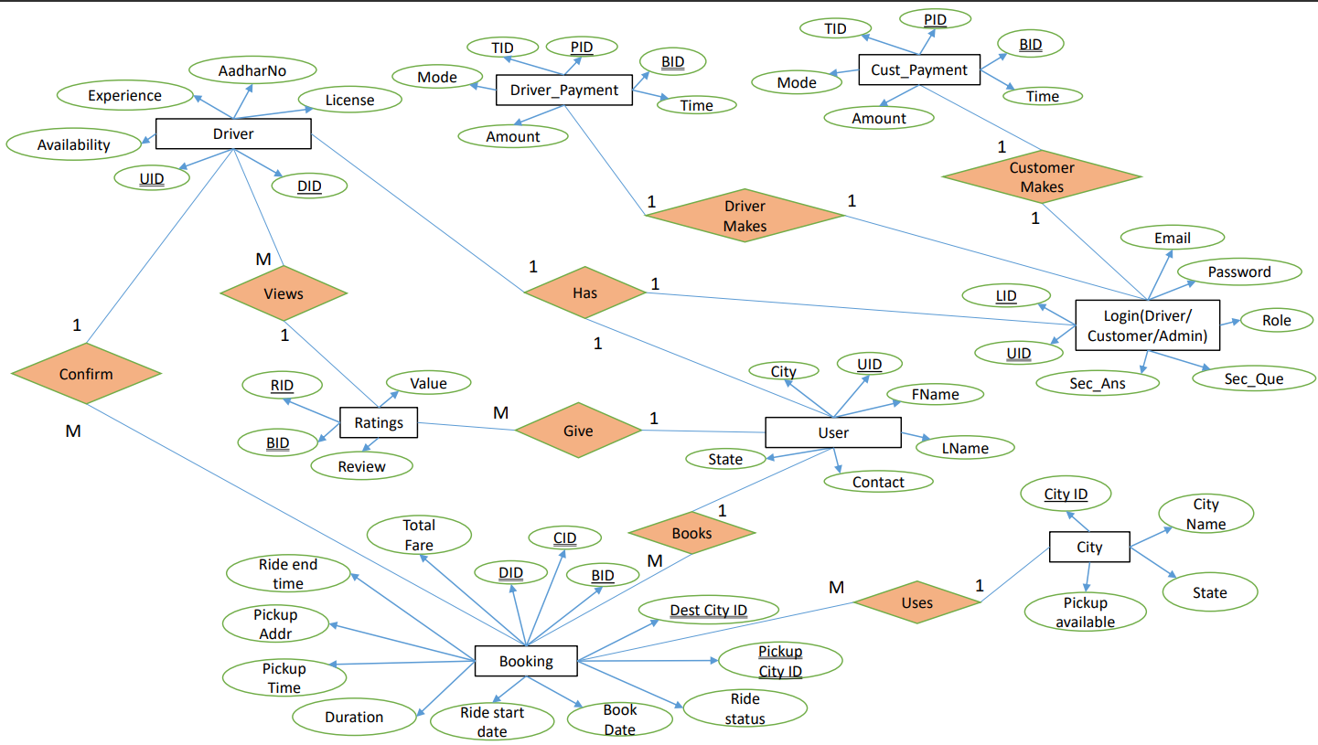

**E-R diagram shows database of Driver On Hire System**

**8. Snapshots:**

**8.1 Home Page:**

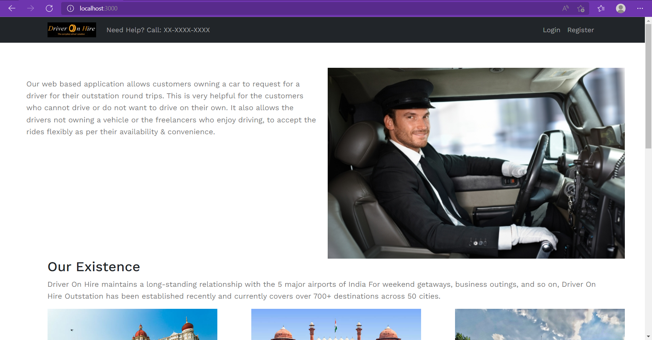

This page contains following controls

* Login
* Register
* Pricing Model
* About Us
* Contact Us
* Why Us
* Terms & Condition
* Privacy Policy

**8.2 Contact Us Page**

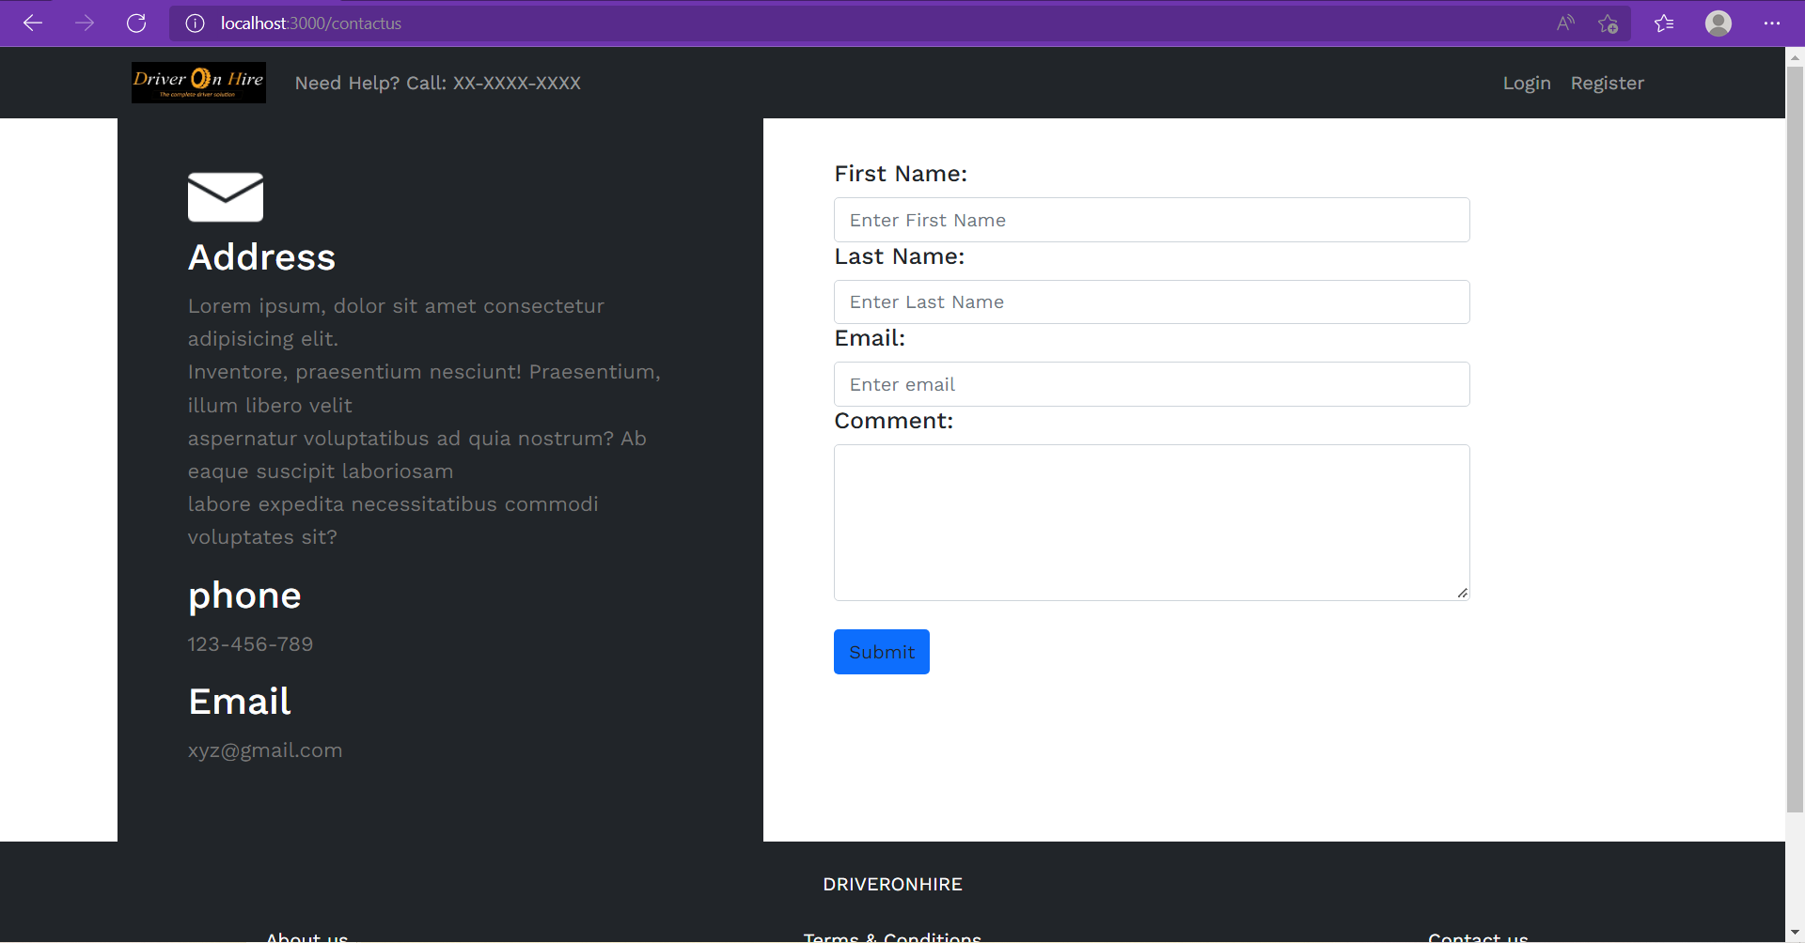

**8.3 Login Page**

Login page is common for Customer, Driver as well as Admin.

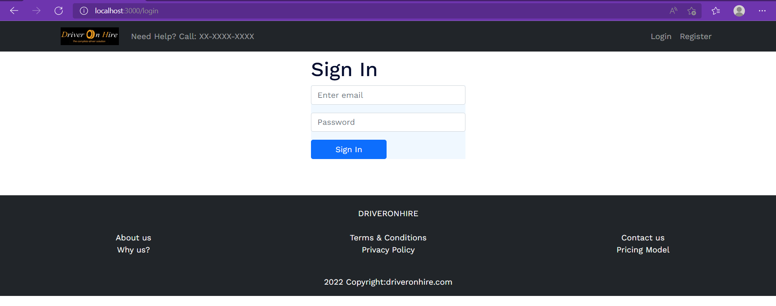

**8.4 Customer Registration Page**

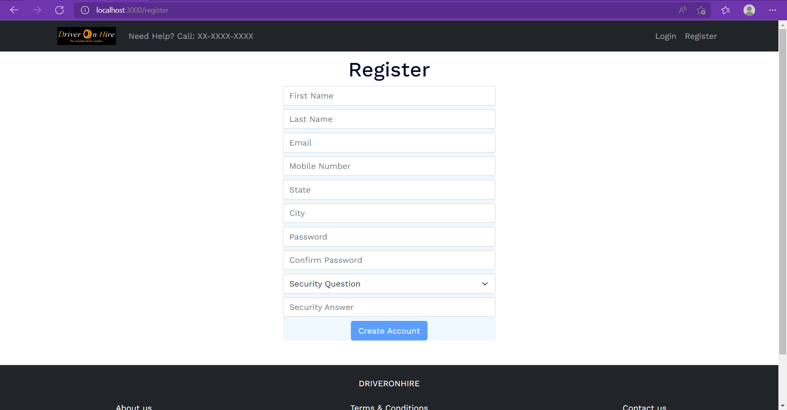

**8.5 Customer Pages:**

**8.5.1 Home Page & Booking page**

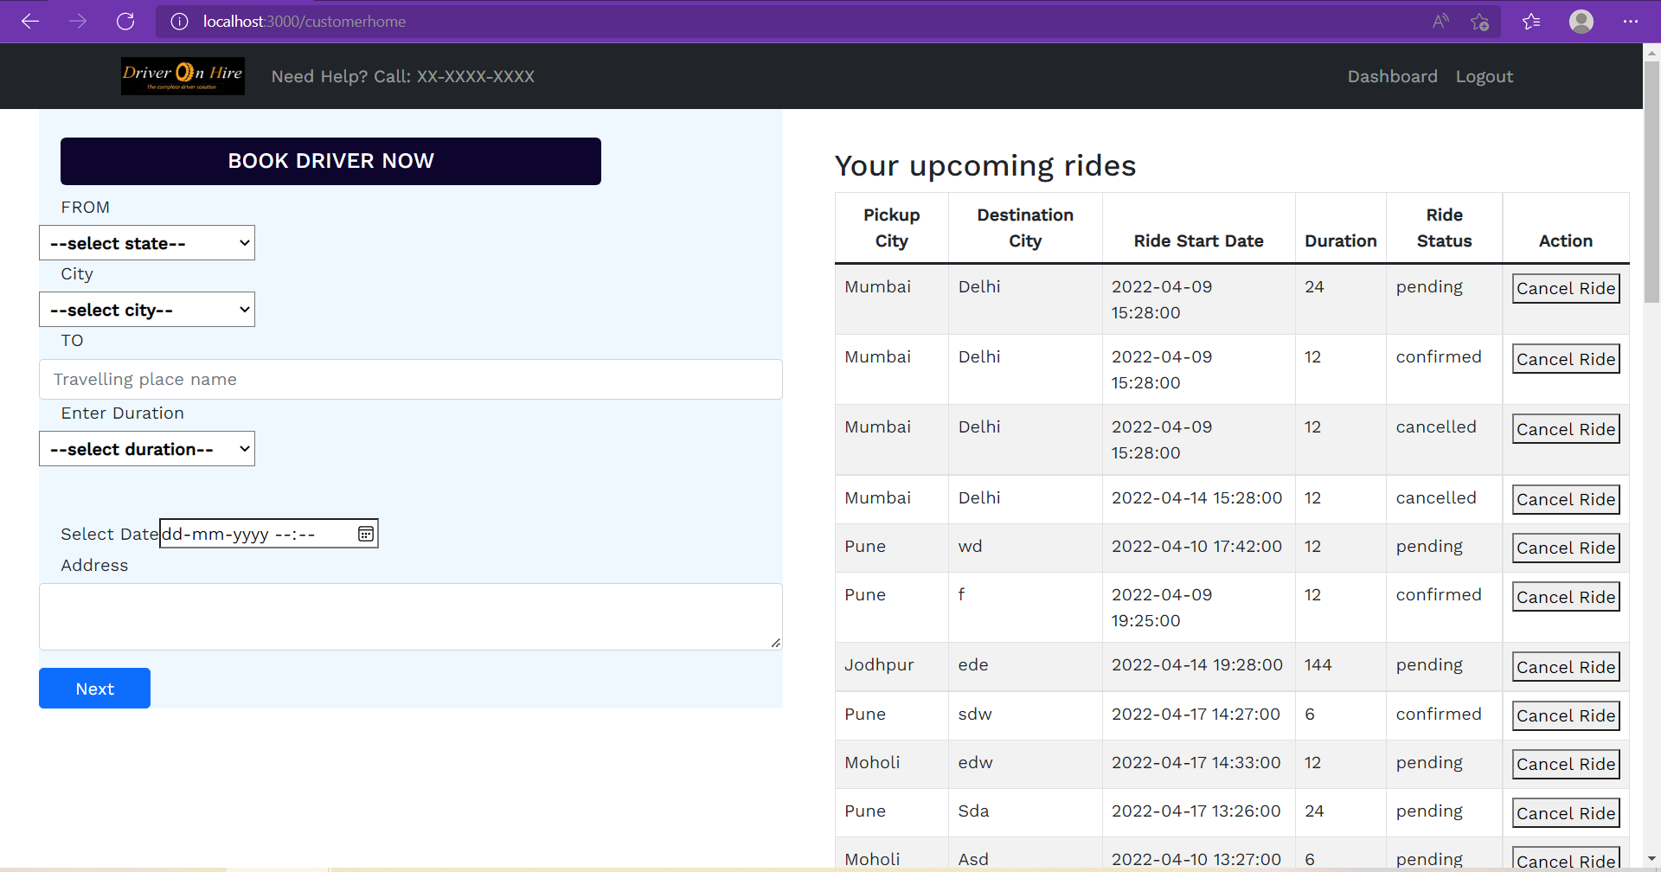

**8.5.2 Booking Summary Page**

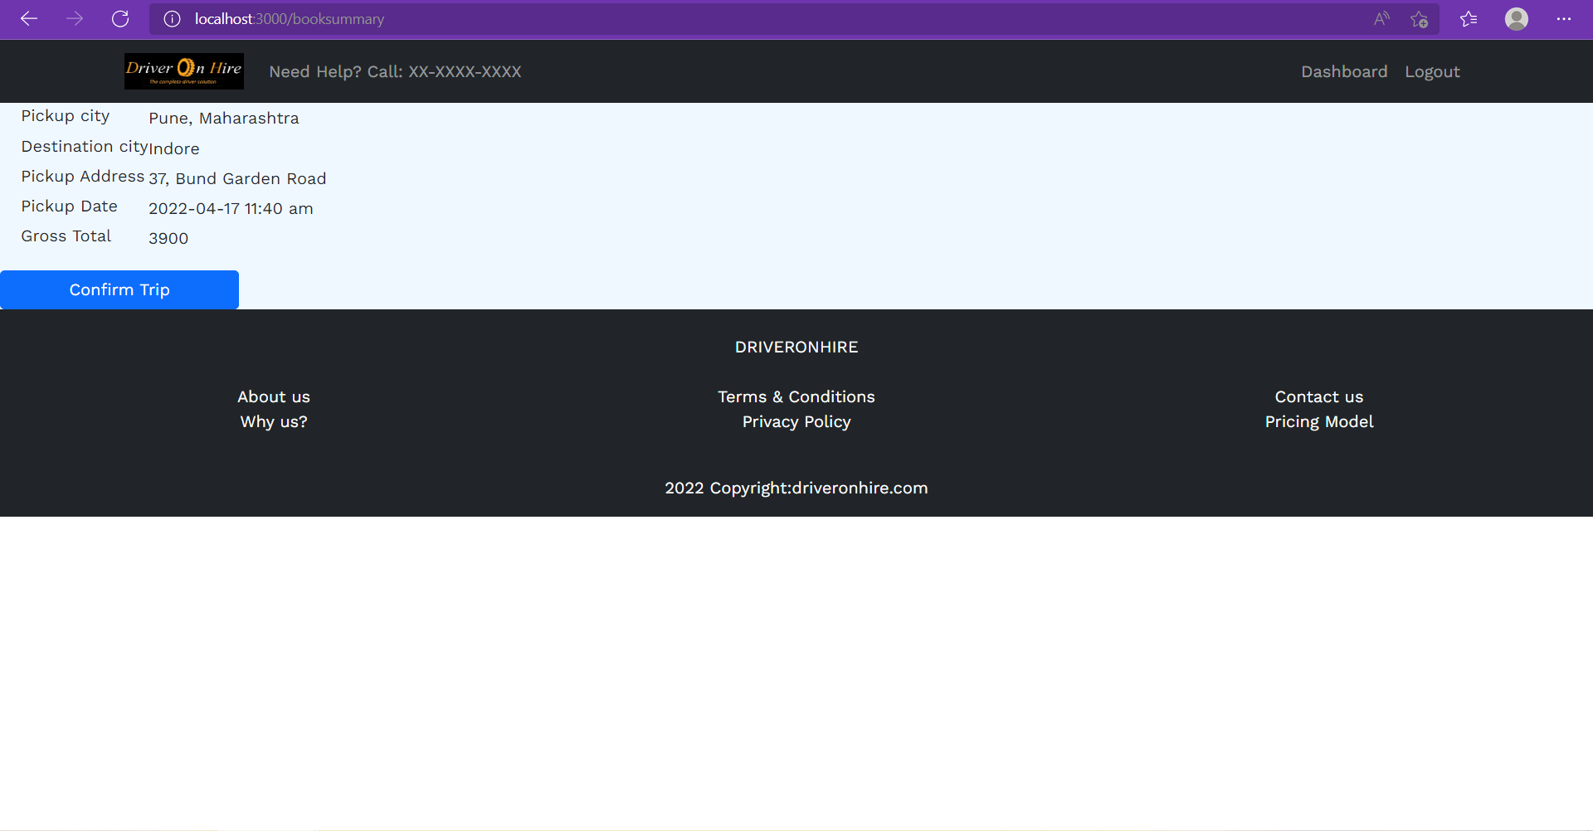

**8.5.3 Customer Dashboard Page**

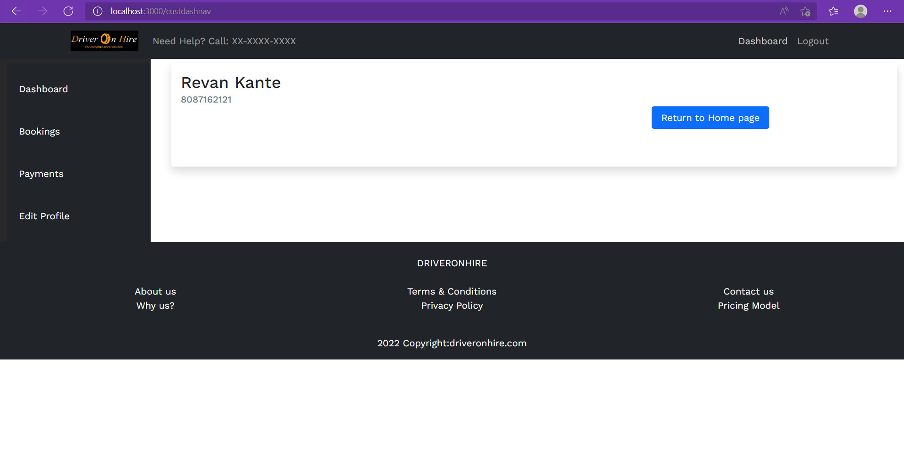

**8.5.4 Customer Bookings Page**

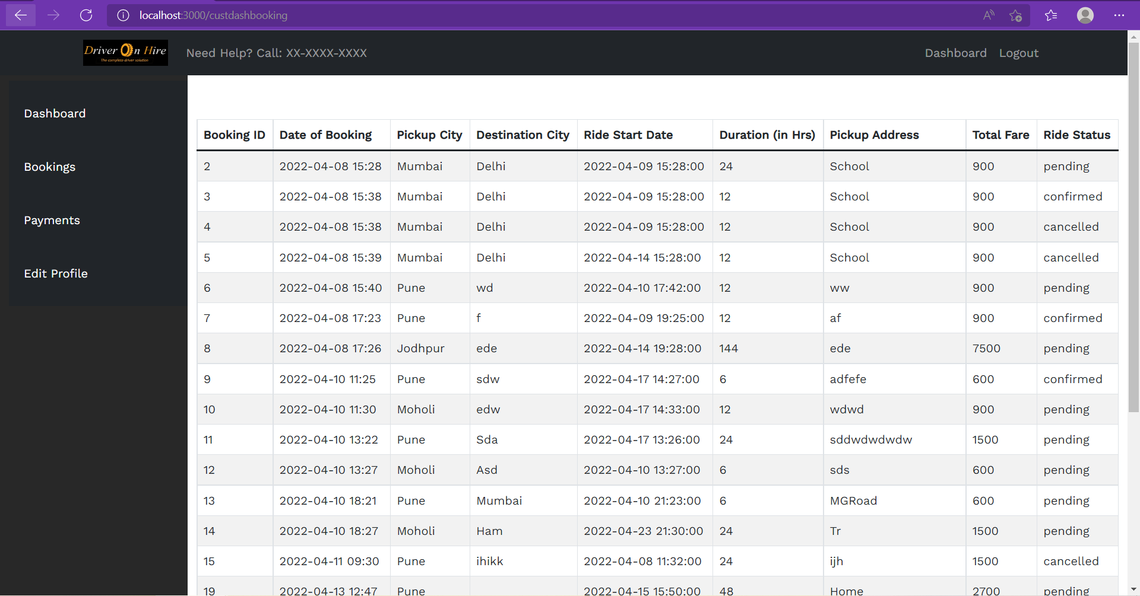

**8.5.5 Profile Updation Page**

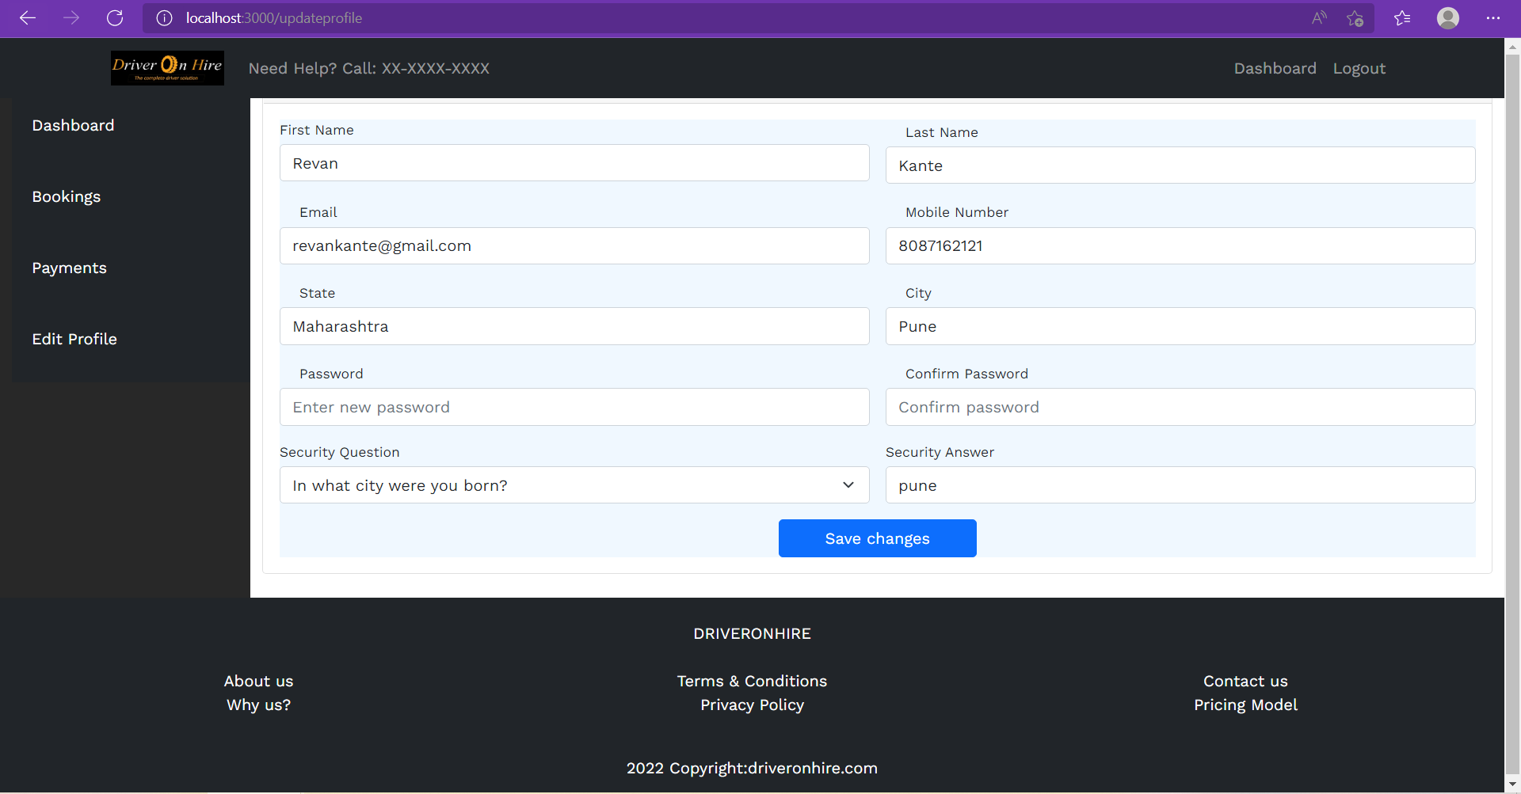

**8.6 Driver Pages:**

**8.6.1 Home Page**

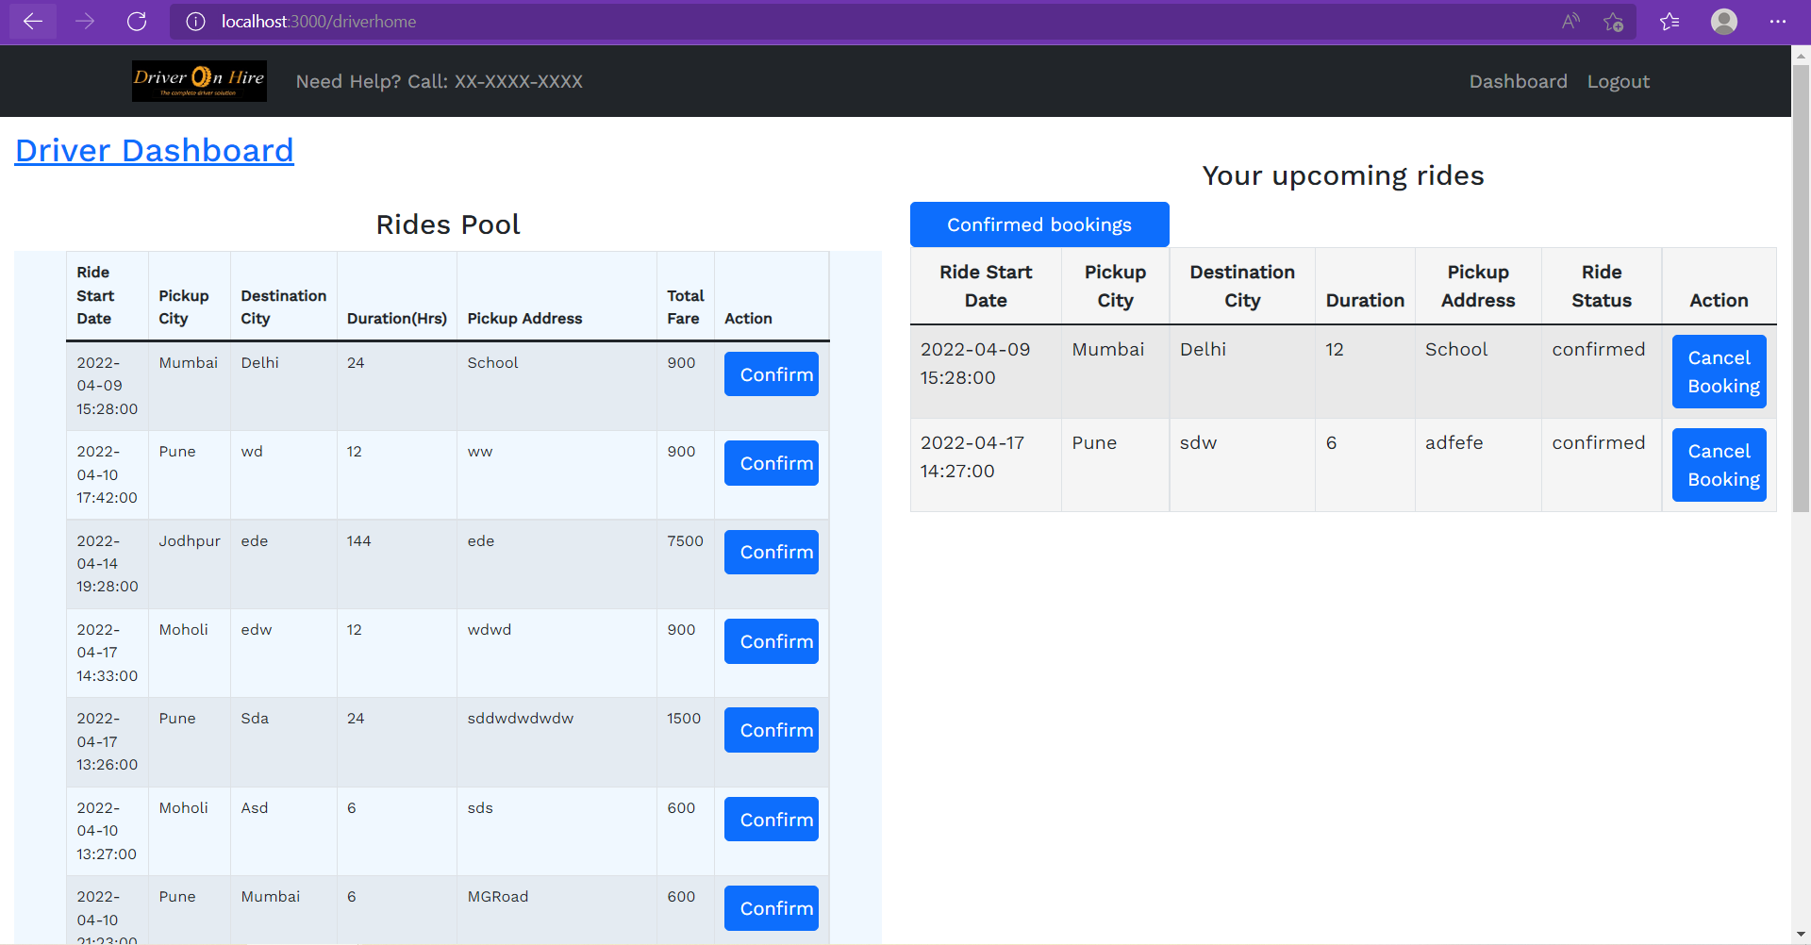

**8.6.2 Driver Dashboard Page**

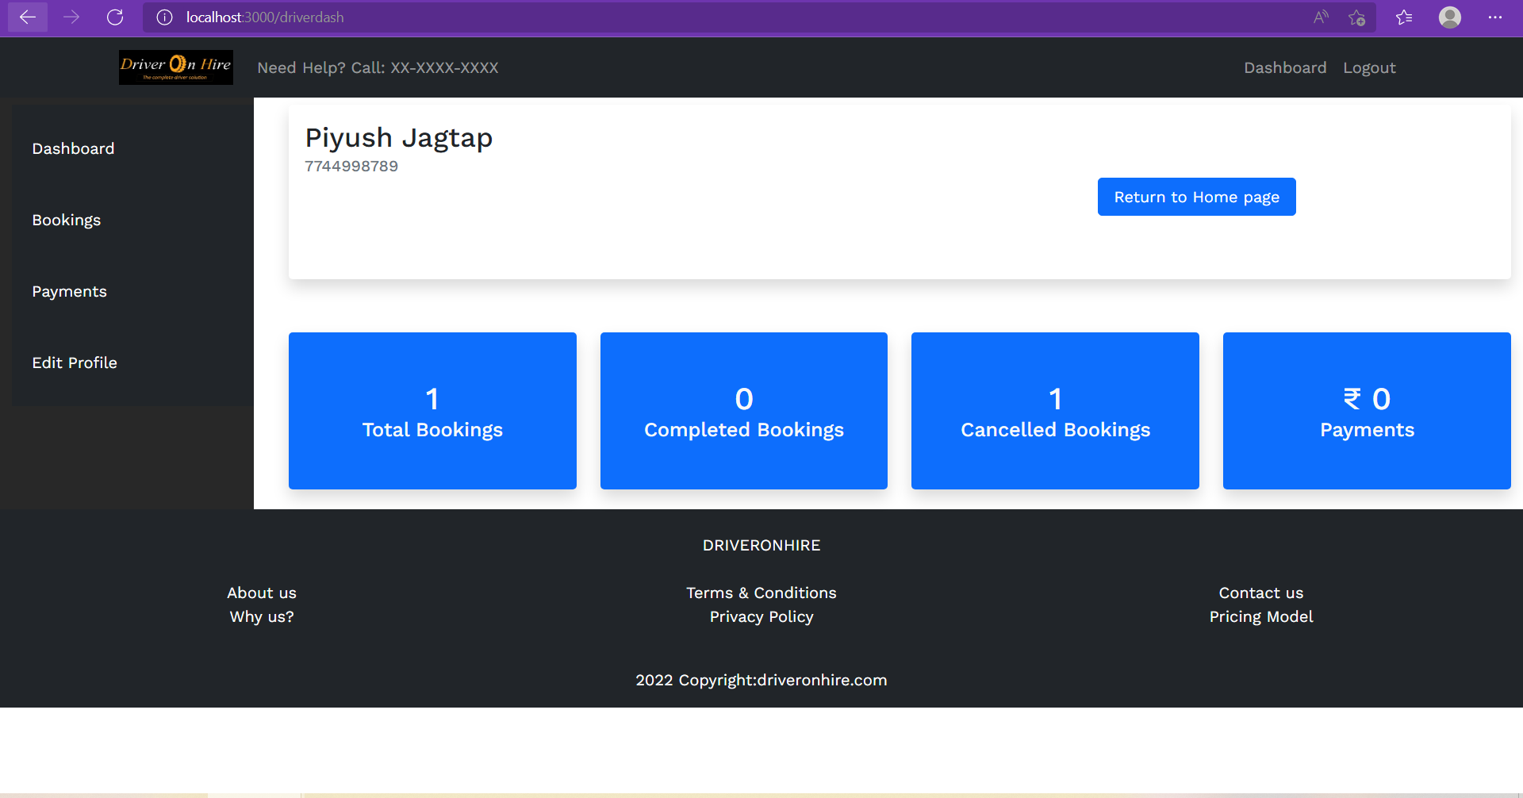

**8.6.3 Driver Bookings Page**

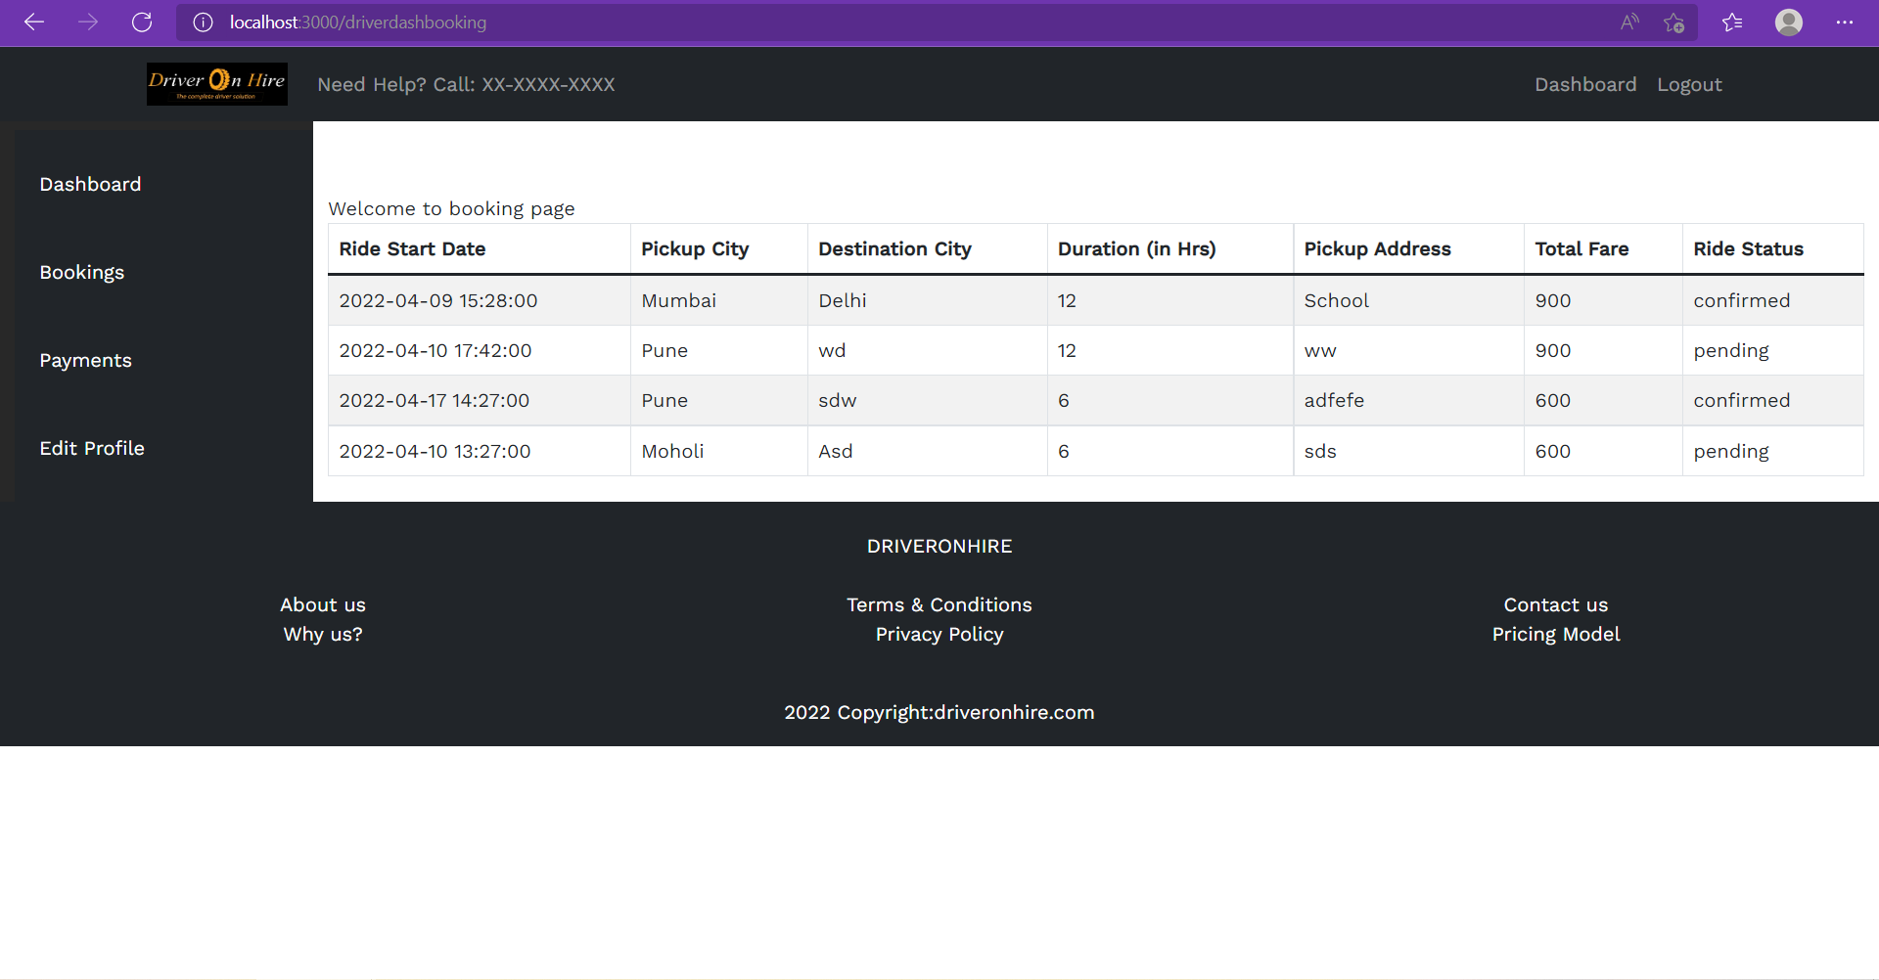

**8.7 Admin Page**

**8.7.1 Home Page**

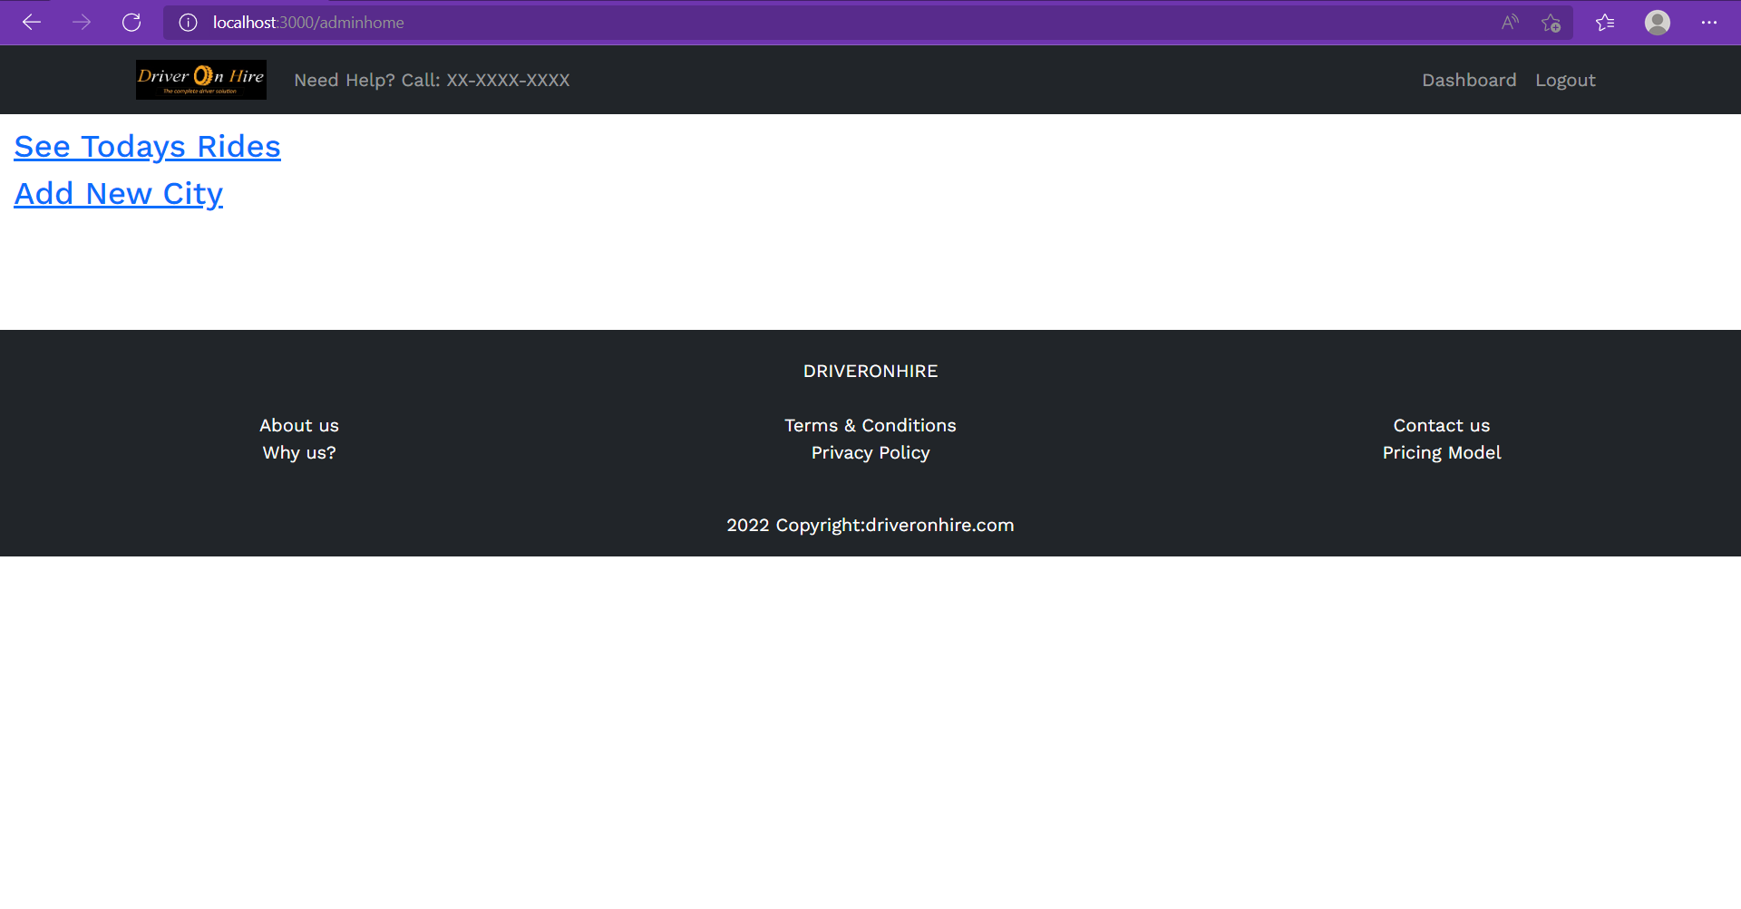

**8.7.2 Todays rides Page**

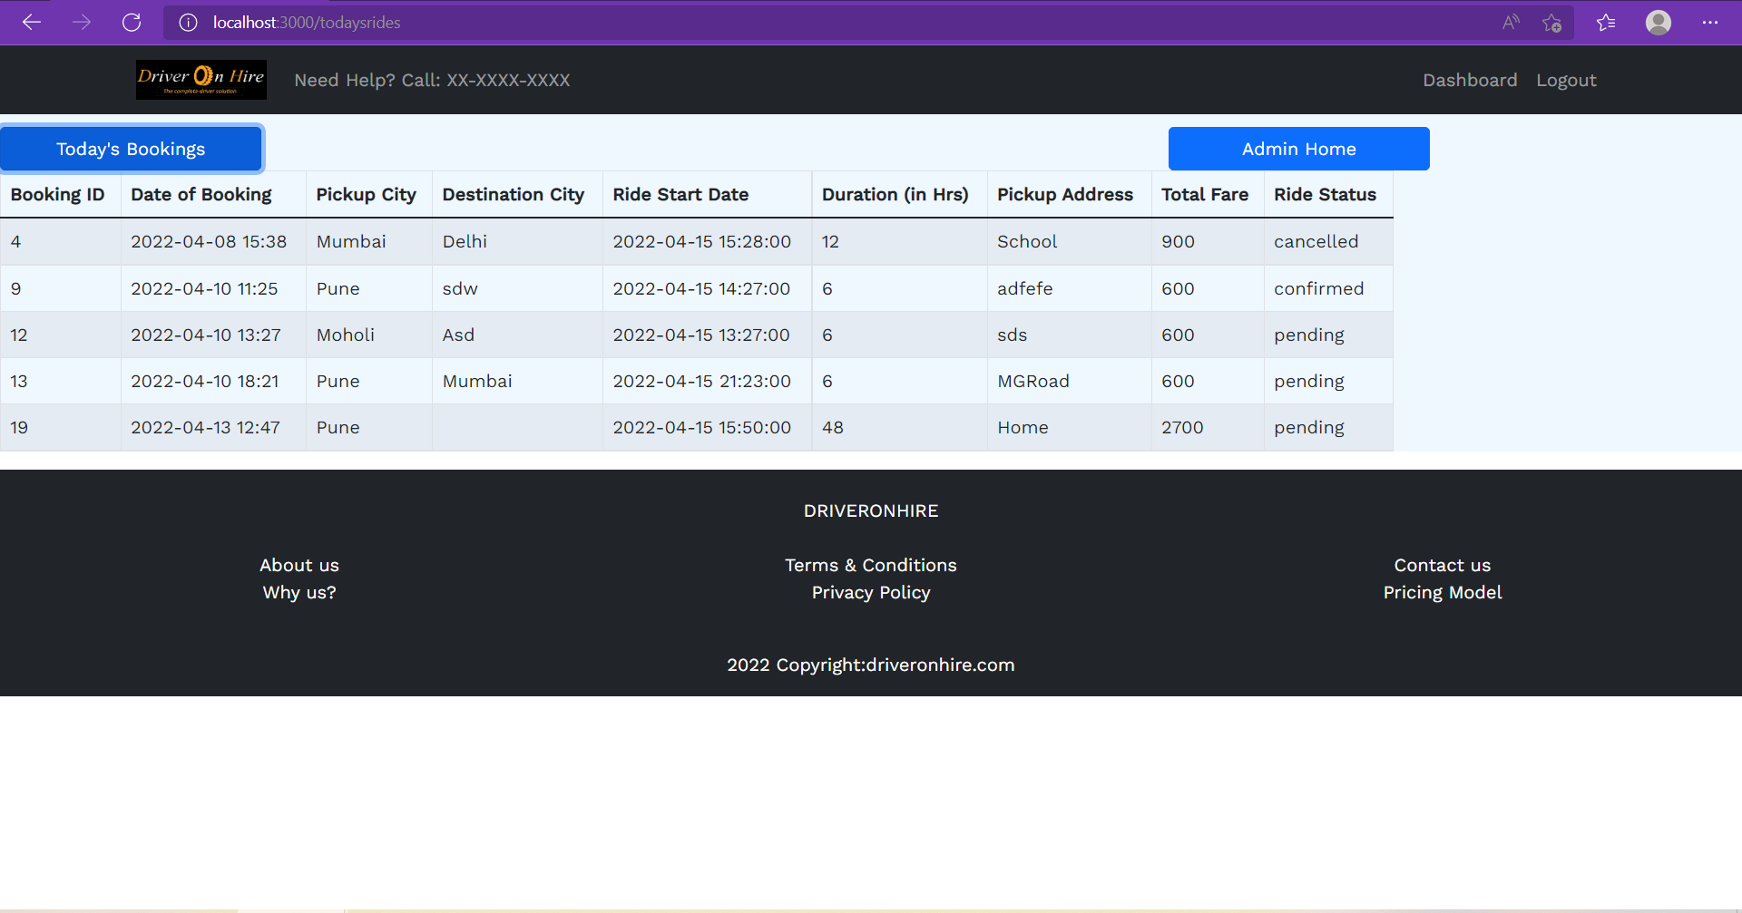

**8.7.3 Add City Page**

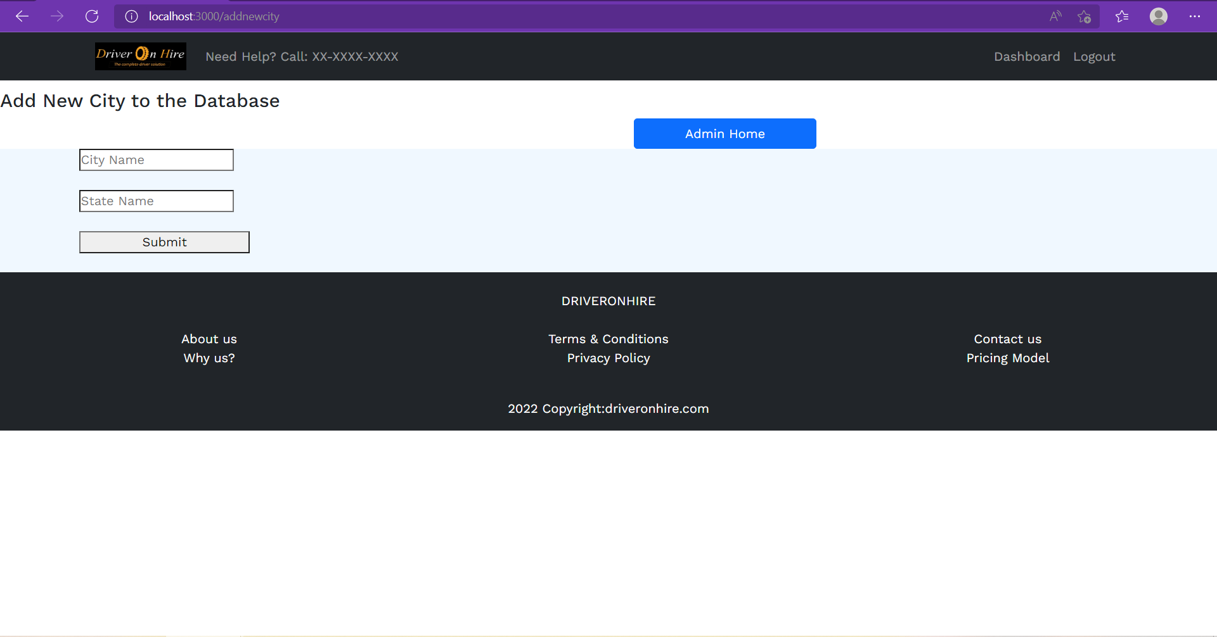

**9. CONCLUSION AND FUTURE SCOPE**

Our Online Driver Hiring system gives customers to easily log their driver booking request for outstation round trips. This is very useful to the customers who have their own vehicles, and they do not want to drive or they are incapable of driving due to physical illness.

This system is also handy for the drivers, who do not own a vehicle and also the freelancers who enjoy driving in weekends. It takes huge investment for a vehicle to buy, so our system will be very much useful to these drivers. The booking confirmation is as per the convenience of drivers, so there will be less number of ride cancellations due to our flexible booking process.

Admin can also track the daily scheduled rides and add new cities as per our business grows.

So overall, we have achieved making a user-friendly, simple yet effective driver booking system.

Adding to this, the system has further scope in online driver onboarding, implementing GPS for ride tracking and customer locality, adding modes of payment, driver ratings & reviews functionality, etc.